The Use of Quizizz as Inductive-based Nahwu Learning Media in the Digital Age

Fadilah Al Azmi^{a,1*}, Muassomah^{b,2}, Nabila Nailil Amalia^{c,3},
Nur Diana^{d,4}
^{a,b,c,d}UIN Maulana Malik Ibrahim Malang, Indonesia
¹fadilahalazmi23@gmail.com, ²muassomah@bsa.uin-malang.ac.id ³naynabila89@gmail.com ⁴nurdianaalmaduriyah@gmail.com

Abstract
In this Digital Era, educators are required to integrate science and technology in all aspects of learning to create effective learning and make it easier for students to understand the material; besides that, with this technology, students can easily find sources of knowledge. One of the Web Tools that are suitable for learning in this Era is Quizizz. This study aims to determine the steps of using Quizizz as an Inductive-based Nahwu learning medium in the Digital Age and to analyze students' perceptions of using Quizizz as an Inductive-based Nahwu learning medium in the Digital Age. This study uses a descriptive qualitative approach. The data collection technique uses documentation and questionnaires. After the data is collected, a descriptive analysis is carried out using: 1) data collection, 2) data reduction, 3) data presentation and 4) conclusion/verification. The results of this study show the steps in using Quizizz as an Inductive-based Nahwu learning media as follows: a). present an example, b). instructed to analyze the example, c). conclude from the examples observed d). make examples related to the material, e). give a quiz using quizizz f). directions for doing g). monitored the results of the answers and the majority of students responded positively to using Quizizz as an Inductive-based Nahwu learning medium in this Digital Age.
Keywords: Quizizz, Inductive-based Nahwu Learning, Digital Era.

استخدامQuizizz كوسائل تعلم النحو على أساس الإستقرائية في العصر الرقمي

Fadilah Al Azmi^{a,1*}, Muassomah^{b,2}, Nabila Nailil Amalia^{c,3},
Nur Diana^{d,4}
^{a,b,c,d}UIN Maulana Malik Ibrahim Malang, Indonesia
¹fadilahalazmi23@gmail.com, ²muassomah@bsa.uin-malang.ac.id ³naynabila89@gmail.com ⁴nurdianaalmaduriyah@gmail.com

الملخص
في هذا العصر الرقمي ، يُطلب من المعلمين أن يكونوا قادرين على دمج العلم والتكنولوجيا في جميع جوانب التعلم من أجل إنشاء تعلم فعال وتسهيل فهم الطلاب للمواد ، إلى جانب أنه باستخدام هذه التكنولوجيا يمكن للطلاب بسهولة العثور على مصادر المعرفة . تعد Quizizz إحدى أدوات الويب المناسبة للتعلم في هذا العصر. تهدف هذه الدراسة إلى تحديد خطوات استخدام Quizizz كوسيط تعلم النحو قائم على الاستقرائية في العصر الرقمي وتحليل تصورات الطلاب لاستخدام Quizizz كوسيط تعلم النحو قائم على الإستقرائية في العصر الرقمي. تستخدم هذه الدراسة المنهج الوصفي النوعي. تستخدم تقنية جمع البيانات التوثيق والاستبيانات. بعد جمع البيانات ، يتم إجراء تحليل وصفي عن طريق: 1) جمع البيانات ، 2) تقليل البيانات ، 3) عرض البيانات ، 4) الاستنتاج / التحقق. تظهر نتائج هذه الدراسة خطوات استخدام Quizizz كوسيلة تعلم النحو قائمة على الاستقرائية على النحو التالي: أ). قدم مثالا ، ب). تعليمات لتحليل المثال ، ج). استخلاص النتائج من الأمثلة الملاحظة د). تقديم أمثلة تتعلق بالمادة هـ). اعطاء اختبار باستخدام Quizizz و). اتجاهات للقيام ز). راقب نتائج الإجابات واستجاب غالبية الطلاب بشكل إيجابي لاستخدام Quizizz كوسيط تعلم النحو قائم على الاستقرائية في هذا العصر الرقمي.
كلمات أساسية: Quizizz، التعلم النحو على أساس الإستقرائية، العصر الرقمي.

Introduction
Education in the Digital Age that occurs in the 21st century requires education implementers to integrate Information and Communication Technology into all aspects of learning. The more advanced technology is, the easier it is to find information. Thus this Era provides an opportunity for all educational participants to obtain various sources of knowledge from various internet sites that allow it to be accessed anywhere and anytime, quickly and easily.. In this Era, with the existence of learning media technology, it will be more sophisticated. Media is any form that is used for a process of channeling information.. Learning media is anything in physical form (hardware) or non-physical form (software) as an intermediary for the learning process to achieve learning objectives. The media that are suitable for this Digital Era are creative, communicative, and collaborative. One of the suitable Web Tools in this Era is Quizizz.
The Quizizz application is a platform used to create interactive games in a learning process. This platform includes applications that are easy to use by educators and lecturers. In addition, this platform can be used as an online-based interactive learning medium.. This Quizizz platform was created in 2015 in India. And used in various countries. This learning is used in the learning process on a platform basis. Anyone can access this Quizizz. Quizizz has two addresses that can be accessed: the address for the admin (teacher) and the address for participants (students). This platform can be accessed free of charge. However, it has paid features..
Research related to the use of Quizizz can attract students' attention to learning learners, and make students active, so Quizizz is very effective in learning in online learning.. In addition, Quizizz can also increase students' interest and concentration in working on science assessments to achieve maximum results.. As for other studies, learning by using Quizizz besides being fun, challenging and interactive can also increase student motivation.. In the research, Ahmad Toni Pratama said that evaluation of learning with Quizizz could increase students' understanding of quantum phenomena material with the result that students' understanding is 52% with a level of understanding, 5% for very understanding and 43% for sufficient understanding.. Quizizz can be used in a variety of learning. One of the lessons that can take advantage of Quizizz is Nahwu learning. Nahwu is one of the most important Arabic language sciences to learn. There are several methods for learning Nahwu Science, one of which is the Istiqraiyah method. The Istiqraiyah method is concluding something specific to something general because this method demonstrates examples and is discussed by students. So inductive - based Nahwu learning is learning that begins by explaining examples related to the material and from these examples students are required to discuss and draw conclusions rules.
The purpose of this study is to complement previous studies with differences between them; previous research focused on the use of Quizizz in learning, while this research focused on the steps in using Quizizz and student perceptions/opinions in using Quizizz as a learning medium. Thus, the objectives of this study can be formulated; what are the steps for using Quizizz as an Inductive-based Nahwu learning media in the Digital Age? And what is the student's perception of using Quizizz as an Inductive-based Nahwu learning medium in the Digital Age?
This research is based on several reasons; learning using Quizizz is very important in learning, especially in this Digital Age, which requires educators to master science and technology in all aspects of learning. In education, the development of science and technology can change conventional learning methods into non-conventional ones. Therefore, learning using Quizizz media will likely take optimal benefits and improve the quality of learning Arabic, especially Nahwu Science.
Method
This qualitative research aims to describe the steps for using Quizizz as an Inductive-based Nahwu learning medium in the Digital Age and to describe students' perceptions of using Quizizz as an Inductive-based Nahwu learning medium in the Digital Age. The measurement scale used in this study is a Likert scale with four indicators, namely 4 (Strongly Agree), 3 (Agree), 2 (Disagree), and 4 (Strongly Disagree). The population of this study were all 3rd-semester students with a sample of 20 students. The researcher chose 3rd semester PBA students at UIN Sultan Syarif Kasim because it was Nahwu material given in 3rd semester and also because the majority of 3rd-semester students who graduated from non-Islamic boarding schools had never studied Arabic, especially Nahwu.
The data collection technique used in this study is documentation in the form of data and information from the Quizizz website (https://quizizz.com/) and questionnaires/questions. Documentation is a method used to obtain data and information in the form of books, archives, documents, written numbers and pictures in the form of reports and information that can support research.. A questionnaire/questionnaire is a data collection technique that gives a set of questions or written statements to the respondent to answer. . Questionnaires or questionnaires are used to collect data. Questionnaires or questionnaires are also used when researchers want to know the changes used when using Quizizz in Inductive-based Nahwu learning. The questionnaire also asked students' opinions about Quizizz media in Inductive-based Nahwu learning. After the data is collected, a descriptive analysis is carried out using: 1) data collection, 2) data reduction, 3) data presentation and 4) conclusion/verification..
Result and Discussion
Steps to Use Quizizz as Inductive-based Nahwu Learning Media in the Digital Age
The steps for using Quizizz as a Nahwu learning medium for 3rd semester Arabic Language Education students at UIN SUSKA Riau are as follows:
Table 1: Steps to Use Inductive-based Nahwu Learning Quizizz
No. | Teacher | Student
1 | The teacher explains several examples of Noun phrase hrough videos on YouTube | Students observe these examples
2 | The teacher instructs students to analyze the observed examples | Students analyze the examples observed
3 | The teacher instructs students to draw conclusions from the examples observed | Students conclude the Ismiyah Sum rule from this example
4 | The teacher instructs students to make examples related to the material | Students to make examples related to the material
5 | The teacher gives a quiz by using quizizz in the Ismiyah Total material | Students start logging into the Quizizz website
6 | The teacher gives an access code to log in | Students enter the code so they can log in to quizizz
7 | The teacher gives instructions or directions for doing the quiz on the Quizizz | Students start working on the quiz given
8 | The teacher monitors the results of student answers | Students complete the quiz given
Table.1 explains that the steps for using Quizizz as a Nahwu learning medium for PBA students in semester three at UIN SUSKA Riau are Inductive based in the Digital Age, namely:
- The teacher presents examples related to the number of Ismiyah while students are required to observe them. The following are examples of Nahwu materials:
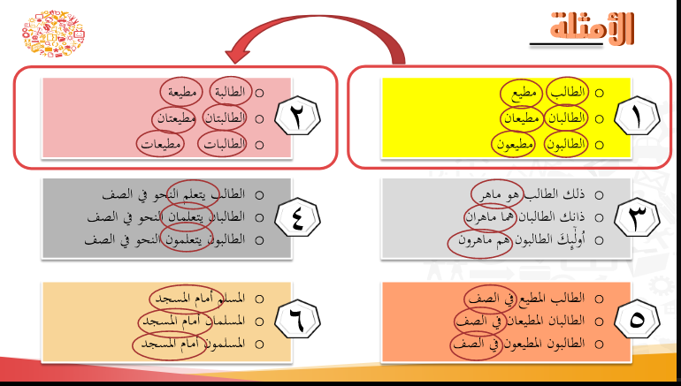

Figure 1: Examples of Ismiyah numbers

The teacher explains the material through examples of the number of Ismiyah via YouTube. After the teacher explained the teacher's examples, students were instructed to observe examples related to the number of Ismiyah.
- The teacher instructs students to analyze the observed examples.

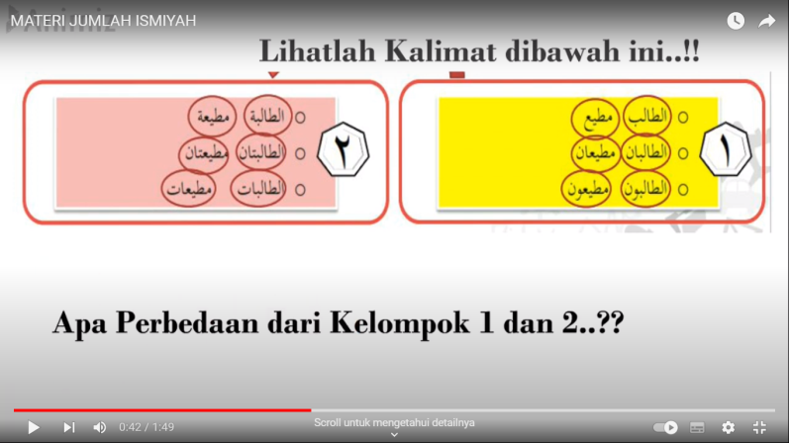

Figure 2: Teacher questions/instructions

After students observe the examples related to the Ismiyah Number, the teacher instructs students to analyze by looking for differences from the examples presented.
- The teacher instructs students to conclude the rules from the differences in these examples.


Figure 3 : Hasil kesimpulan
After students can analyze these examples, the teacher appreciates students who can draw conclusions from the examples and then explain them again to the teacher.
- The teacher instructs students to make examples related to the material.

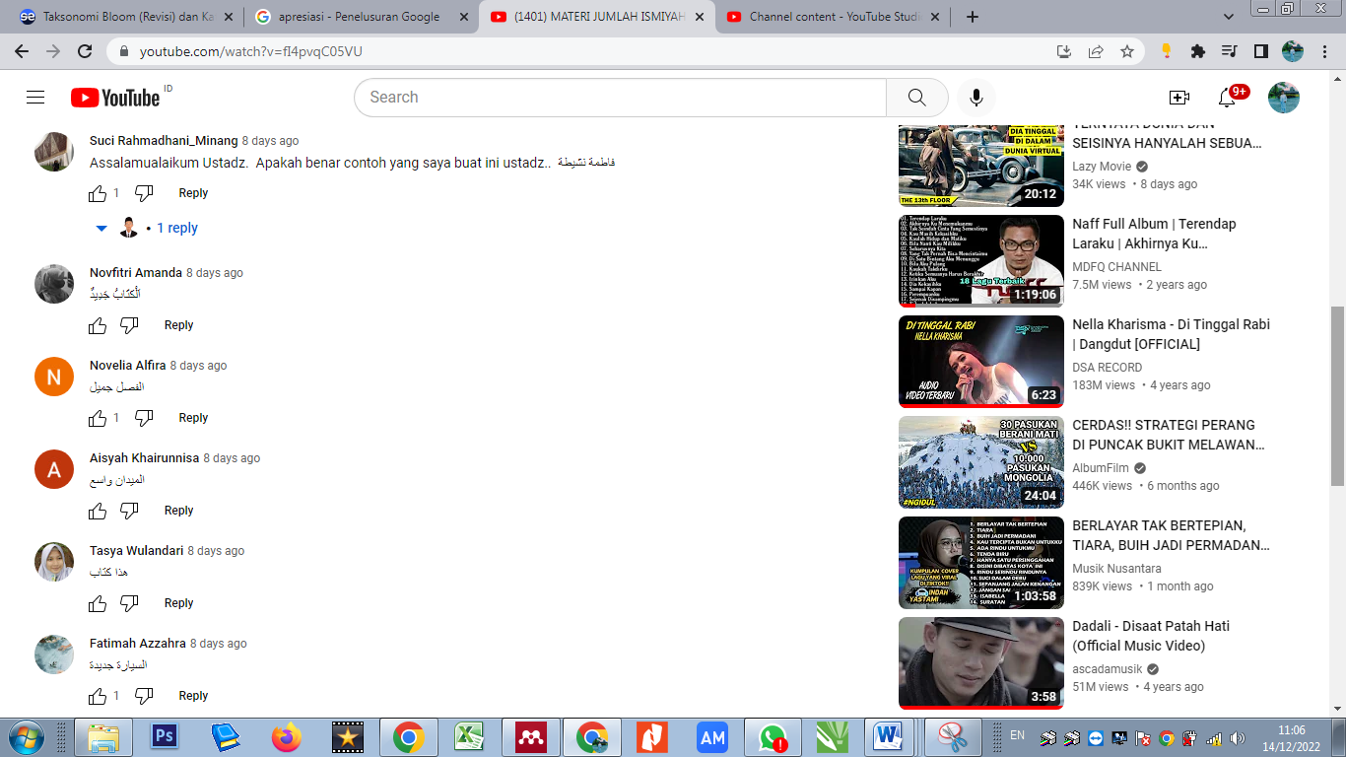

Figure 4: Examples from students
After students draw conclusions and understand related to the Sum of Ismiyah material, students are instructed to make examples of what they have understood in the Youtube comments column.
- Teachers give quizzes using Quizizz in the Ismiyah Total material for special teachers opening a link (https://quizizz.com/admin) as an admin in making quizzes and monitoring the results of student answers, specifically for students opening a link (https://quizizz. com/join/) to start playing the quiz.

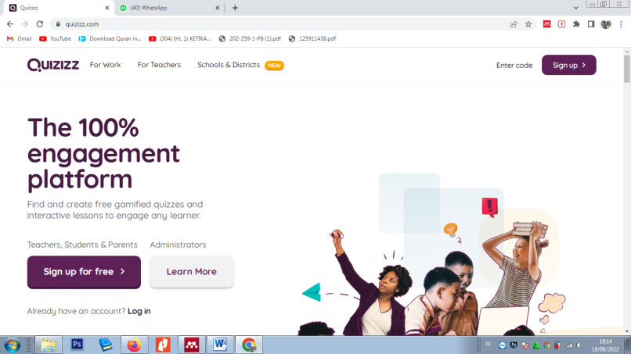

Figure 5 : website Quizizz
After giving and understanding the material, students are given questions in the form of quizzes related to the number of Ismiyah so that the teacher can find out the ability of students to understand the material.
- The teacher gives an access code to log in
Here is the code and the Quizizz link
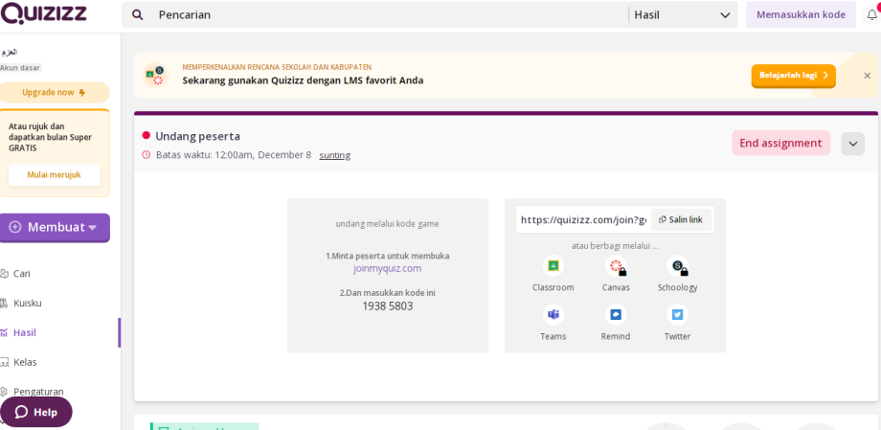

Figure 6 : Halaman awal Quizizz
After students opened the link (https://quizizz.com/admin), a teacher gave students an access code to log in to Quizizz. Next, students enter the code so they can enter Quizizz.
- The teacher gives instructions or directions for doing the quiz on the Quizizz.
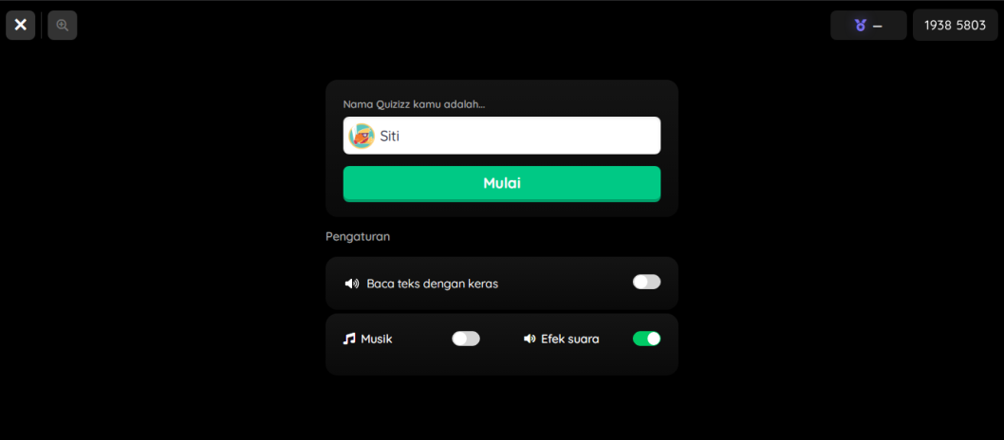

Figure 7 : Halaman masukkan Kode

The teacher gives instructions or directions to students via their respective cellphones to access Quizizz with the code given. Students can work on these multiple-choice questions within 20 seconds for every 1 question. So those students answering questions must be fast and accurate.
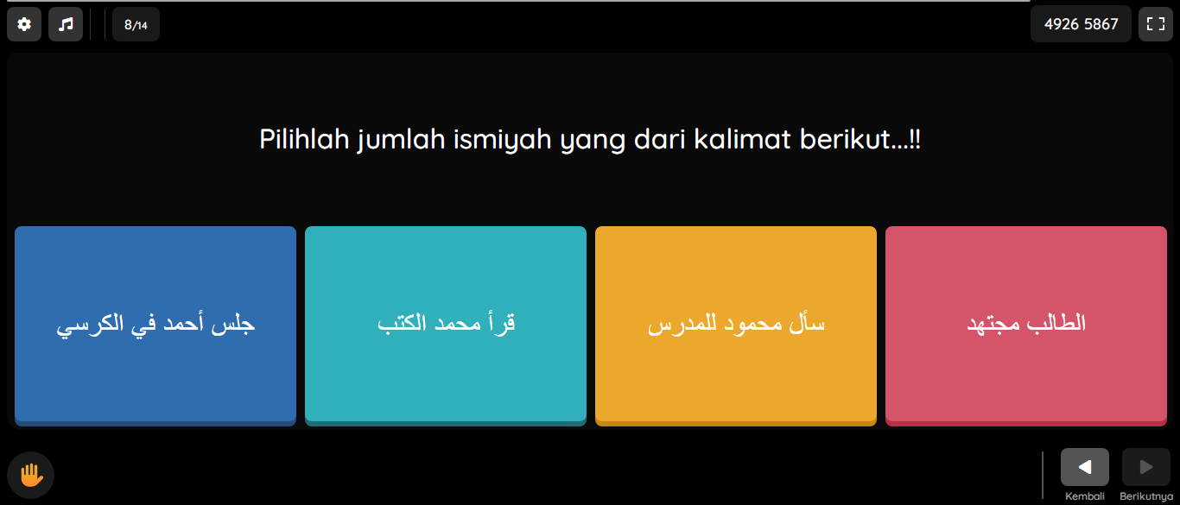

Figure 8: Nahwu Quiz questions

After students log in, the teacher instructs students to work on the questions that have been provided. The teacher monitors the course of the quiz and can see the results of students answering several questions related to the number of Ismiyah.
- The teacher monitors the results of student answers.
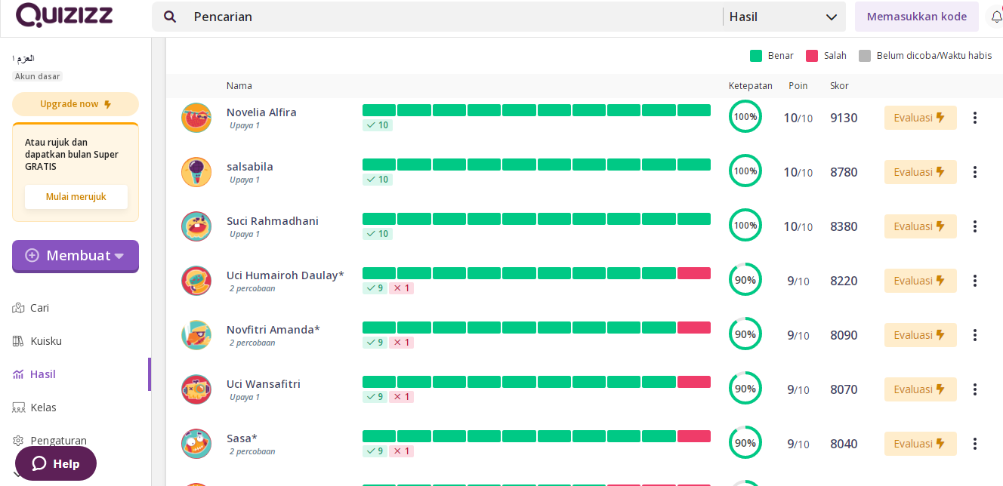

Figure 9: Results of Student Answers
At this stage, the teacher can see the scores of all students so that the teacher knows whether students understand or not about the Ismiyah Number. The teacher gives the highest score of 100 points.
Student Perceptions of Using Quizizz as Inductive-based Nahwu Learning Media in the Digital Age
Research on student perceptions produced data on the results of filling out questionnaires/questions by 20 PBA Semester 3 students at UIN SUSKA Riau. The data for filling in the questionnaire/questionnaire by students is as follows:
Table 2: Results of Student Perception Questionnaire / Questionnaire Data
No. | Statement | 4 | 3 | 2 | 1 | Results %
1 | College students love Quizizz quizzes | 7 | 10 | 3 | 0 | 80%
2 | Quizizz quiz questions are easy. | 9 | 11 | 0 | 0 | 86,25%
3 | With Quizizz, the learning atmosphere of Nahwu Science is interesting | 8 | 10 | 2 | 0 | 82,5%
4 | Nahwu science becomes a fun lesson by using Quizizz media | 8 | 10 | 2 | 0 | 82,5%
5 | Quizizz can help learn Nahwu Science | 8 | 11 | 1 | 0 | 83,75%
6 | Quizizz is an exciting quiz in learning Nahwu Science | 7 | 11 | 2 | 0 | 81,25%
7 | Mahasiswa dapat memahami Ilmu Nahwu dengan Quizizz | 5 | 12 | 3 | 0 | 77,5%
8 | Students can take Quizizz quizzes to learn Nahwu Science | 9 | 11 | 0 | 0 | 86,25%
9 | Students work quickly and accurately learning Nahwu Science with Quizizz media | 9 | 11 | 0 | 0 | 86,25%
10 | Students can actively participate in learning Nahwu Science with Quizizz | 14 | 6 | 0 | 0 | 92,5%
There are four responses on the questionnaire sheet: number 4 indicates strongly agree, number 3 indicates agree, number 2 indicates agree, and number 1 indicates strongly disagree. The four responses can be classified into two categories, namely positive responses for the answers "strongly agree" and "agree" and negative responses for the answers "disagree" and "strongly disagree".
Table 2 shows that most students respond positively to using Quizizz as an Inductive-based Nahwu learning medium in the Digital Age. However, some students disagree with the statements written in the research questionnaire. Most students like learning with Quizizz, with eight strongly agreeing and ten who agree. Whereas two people who responded negatively felt they did not like learning Nahwu with Quizizz, the results showed 80%. All students thought that using Quizizz was easy. This is evidenced by the positive response from all students, with a percentage of 86.25% of students. In line with Salsabila's research, she said that Quizizz, which has educational value, can provide students with innovative learning that will make it easier to carry out learning in class.. According to most students, Quizizz can make learning Nahwu more interesting, as evidenced by 18 students who gave positive responses and two people who responded negatively who disagreed with the results of 82.5%. In addition, most students responded positively that learning with Quizizz made learning more enjoyable, with 18 students who responded positively. In comparison, two students responded negatively, with a result of 82.5%. With Quizizz, there can be interaction when students work on learning evaluations, so students feel motivated to evaluate and happy.. In addition, most students stated that learning using Quizizz was more exciting, 18 students responded positively, and two responded negatively, who disagreed with the statement, and the result was 81.25%.
Quizizz can help to learn, especially learning Nahwu for UIN SUSKA Riau students as evidenced by the large number of students who responded positively to the questionnaire statements, namely 19 students, while 1 person disagreed with this statement, with results showing 83.75%. Apart from that, the majority of students stated that learning Nahwu using Quizizz can make it easier to understand learning Nahwu. This is evidenced by the many positive responses, namely 17 students and three people who responded negatively disagreed with the statement, with 77.5%. Kalahatu's research says that learning evaluation using Quizizz is very effective, where the pre-test results related to participants' understanding of anti-corruption material are 44%, and the post-test results increase to 71% or an increase of 27%.. All students stated a positive response to being able to do Quizizz quizzes in learning Nahwu Science. In fact, all students are able to do Nahwu learning with Quizizz media quickly and precisely. This can be proven by the positive response of all students to this statement, with the result being 86.25%. In addition, all students stated that Quizizz in learning Nahwu could make all students participate actively. Namely, 15 students strongly agreed, and five agreed with the statement, 92.5%. This is reinforced by Wahyudi's opinion that Quizizz can be used as an alternative to learning assessment..
Based on the results of the questionnaire/questionnaire, it can be concluded that UIN SUSKA Riau students who respond positively to learning Nahwu with Quizizz in the Digital Age more than students who respond negatively. Students like learning by using Quizizz. In use, it feels effortless and straightforward. Quizizz can make the Nahwu learning atmosphere more interesting so that learning is more fun and exciting. In addition, Quizizz can help students learn, especially learning Nahwu, making it easier for them to understand Nahwu material. All students can take Quizizz quizzes in learning Nahwu. Even all students can participate actively in learning.
Conclusion
Technology in the Digital Age has influenced aspects of education and learning so that it can help the learning process, so teachers use media in learning. Learning media is more than just fixated on blackboards, books, and others. Now teachers can take advantage of technology as a medium. One of them is using Quizizz. Quizizz-based learning is game-based learning. This quiz must use the internet or an online network. The steps in using Quizizz as an Inductive-based Nahwu learning media are as follows: a). present an example, b). instructed to analyze the example, c). conclude from the examples observed d). make examples related to the material, e). giving quizzes using Quizizz, f). directions for doing g). monitor the results
It can be seen from the results of the questionnaire that the majority of students respond positively to the use of Quizizz as an Inductive-based Nahwu learning media in this Digital Era; for example, students like learning with Quizizz, making learning fun, fun and even making it easier to understand learning, can make students participate actively in learning.
This research is limited to describing the steps for using Quizizz as a medium for learning Nahwu and students' responses to using Quizizz. In line with that, this study suggests further research to apply Quizizz in other learning to find out the effectiveness of Quizizz in learning.

References
Azzuhri, Muhandis. "Metode Dan Media Pembelajaran Bahasa Arab Berbasis Internet Di Era Teknologi Informasi". Insania : Jurnal Pemikiran Alternatif Kependidikan 14, No. 3 (1970): 348–445.
Fabiana Meijon Fadul. Pembelajaran Digital. Widina Bhakti Persada Bandung, 2019.
Kalahatu, Marsye Fera. "Persepsi Peserta Pelatihan Dasar Terhadap Penggunaan Quizizz Sebagai Metode Evaluasi Pembelajaran". Akademika (2021).
Lailah, Izzatul. "طرائق تدريس علم النحو واستراتيجياا الفعالة". At-Tadris 4, No. 1 (2016).
Lexy, Moleong. Metode Penelitian Kualitatif. Bandung: Cv. Remaja, 2002.
Mintarsih, H. "Pemanfaatan Aplikasi Quizizz Berbasis Smartphone Dalam Meningkatkan Motivasi Belajar Siswa Smk". Seminar Nasional Pendidikan (2020).
Pratama, Ahmad Toni, Nana Nana, و Dwi Sulistyaningsih. "Pemanfaatan Aplikasi Quizziz Dalam Pembelajaran Fisika Pada Materi Fenomena Kuantum". Edufisika 6, No. 1 (2021): 34–40.
Pusparani, Herlina. "Media Quizizz Sebagai Aplikasi Evaluasi Pembelajaran Kelas Vi Di Sdn Guntur Kota Cirebon". Tunas Nusantara (2020).
Rahmawati, Dhian Nuri, Ana Fitrotun Nisa, Dwi Astuti, Fajariyani Fajariyani, و Suliyanti Suliyanti. "Pemanfaatan Aplikasi Quizizz Sebagai Media Penilaian Pembelajaran Ilmu Pengetahuan Alam". Dawuh Guru: Jurnal Pendidikan Mi/Sd (2022).
Salsabila, Unik Hanifah, Iefone Shiflana Habiba, Isti Lailatul Amanah, Nur Asih Istiqomah, و Salsabila Difany. "Pemanfaatan Aplikasi Quizizz Sebagai Media Pembelajaran Ditengah Pandemi Pada Siswa Sma". Jurnal Ilmiah Ilmu Terapan Universitas Jambi|Jiituj| 4, No. 2 (2020): 163–173.
———. "Pemanfaatan Aplikasi Quizizz Sebagai Media Pembelajaran Ditengah Pandemi Pada Siswa Sma". Jurnal Ilmiah Ilmu Terapan Universitas Jambi|Jiituj| (2020).
Sugiyono. Metode Penelitian Kuantitatif Kualitatif Dan R&D. Bandung: Al-Fabeta, 2020.
———. Metode Penelitian Pendidikan Pendekatan Kuantitatif, Kualitatif, Dan R&D. Bandung: Alfabeta, 2017.
Wahyudi, Wahyudi, Intan Sari Rufiana, و Dwi Avita Nurhidayah. "Quizizz: Alternatif Penilaian Di Masa Pandemi Covid-19". Jurnal Ilmiah Soulmath : Jurnal Edukasi Pendidikan Matematika (2020).
Zulpina, Zulpina. "Quizizz, Media Alternatif Pembelajaran Bahasa Arab Online Bagi Siswa Madrasah Ibtidaiyah". Al-Madrasah: Jurnal Pendidikan Madrasah Ibtidaiyah 6, No. 3 (2022): 775.
حنفى, عبد الحليم. طرق التعليم اللغة العربية، 2001 ص: 20. بتوسيكر،, د.ت.

Fabiana Meijon Fadul, Pembelajaran Digital (Widina Bhakti Persada Bandung, 2019).
Muhandis Azzuhri, "Metode Dan Media Pembelajaran Bahasa Arab Berbasis Internet Di Era Teknologi Informasi", Insania : Jurnal Pemikiran Alternatif Kependidikan 14, عدد 3 (1970): 348–445.
Zulpina Zulpina, "Quizizz, Media Alternatif Pembelajaran Bahasa Arab Online Bagi Siswa Madrasah Ibtidaiyah", Al-Madrasah: Jurnal Pendidikan Madrasah Ibtidaiyah 6, عدد 3 (2022): 775.
Website Quizizz
Unik Hanifah Salsabila وآخ., "Pemanfaatan Aplikasi Quizizz Sebagai Media Pembelajaran Ditengah Pandemi Pada Siswa Sma", Jurnal Ilmiah Ilmu Terapan Universitas Jambi|Jiituj| 4, عدد 2 (2020): 163–173.
Dhian Nuri Rahmawati وآخ., "Pemanfaatan Aplikasi Quizizz Sebagai Media Penilaian Pembelajaran Ilmu Pengetahuan Alam", Dawuh Guru: Jurnal Pendidikan Mi/Sd (2022).
H Mintarsih, "Pemanfaatan Aplikasi Quizizz Berbasis Smartphone Dalam Meningkatkan Motivasi Belajar Siswa Smk", Seminar Nasional Pendidikan (2020).
Ahmad Toni Pratama, Nana Nana, و Dwi Sulistyaningsih, "Pemanfaatan Aplikasi Quizziz Dalam Pembelajaran Fisika Pada Materi Fenomena Kuantum", Edufisika 6, عدد 1 (2021): 34–40.
Izzatul Lailah, "طرائق تدريس علم النحو واستراتيجياا الفعالة", At-Tadris 4, عدد 1 (2016).
عبد الحليم حنفى, طرق التعليم اللغة العربية، بتوسيكر 2001 ص: 20.
Sugiyono, Metode penelitian pendidikan Pendekatan kuantitatif, kualitatif, dan R&D (Bandung: Alfabeta, 2017).
Sugiyono, metode penelitian kuantitatif kualitatif dan R&D (Bandung: Al-fabeta, 2020).
Moleong Lexy, Metode Penelitian Kualitatif (Bandung: CV. Remaja, 2002).
Unik Hanifah Salsabila وآخ., "Pemanfaatan Aplikasi Quizizz Sebagai Media Pembelajaran Ditengah Pandemi Pada Siswa Sma", Jurnal Ilmiah Ilmu Terapan Universitas Jambi|Jiituj| (2020).
Herlina Pusparani, "Media Quizizz Sebagai Aplikasi Evaluasi Pembelajaran Kelas Vi Di Sdn Guntur Kota Cirebon", Tunas Nusantara (2020).
Marsye Fera Kalahatu, "Persepsi Peserta Pelatihan Dasar Terhadap Penggunaan Quizizz Sebagai Metode Evaluasi Pembelajaran", Akademika (2021).
Wahyudi Wahyudi, Intan Sari Rufiana, و Dwi Avita Nurhidayah, "Quizizz: Alternatif Penilaian Di Masa Pandemi Covid-19", Jurnal Ilmiah Soulmath : Jurnal Edukasi Pendidikan Matematika (2020).

